**Team Pi**

**Team Members**

| **Name** | **Section** | **SJSU ID** |
| --- | --- | --- |
| [Neel Desai](mailto:neel.b.desai@sjsu.edu) | Sec 49 | 017436575 |
| [Samarth Sharma](mailto:samarthshyamsundar.sharma@sjsu.edu) | Sec 49 | 017103437 |
| [Raviraj Tushar Wadnerkar](mailto:ravirajtushar.wadnerkar@sjsu.edu) | Sec 48 | 017458935 |
| [Mansi Vekariya](mailto:mansimaheshbhai.vekariya@sjsu.edu) | Sec 49 | 016996291 |

**Jira Board**

https://sjsu-neelbdesai.atlassian.net/jira/software/projects/PI2/boards/2

**Daily Scrum and Sprint Backlogs**

[Team-Pi-daily_Scrum](https://docs.google.com/spreadsheets/d/1M-AHg6bkipqlLfJwHR379_nuPb-DocOJvQZ-A-sN0Wg/edit?usp=sharing)

**Work Distribution**

The work has been distributed based on features, the person owning the feature is responsible for both the front-end and back-end of the feature.

| Neel Desai | Setting Up Jira |
| --- | --- |
| Converting all required features to user stories |
| Creating a boilerplate that can used for the homepage for all roles |
| A student should be able to see the courses they have enrolled in current and previous sem |
| Students should be able to view their own scores for their enrolled subjects |
| For one student generate enough mock data to demonstrate all feature |
| A student should be able to see the published assignments and quizzes for a course |
| A student should be able to see the content of all the courses published |
| Samarth Sharma | Create UI Mock-Ups |
| Admin should be able to see courses taught by faculty in the current and previous semester |
| For One faculty generate enough Mock data to demonstrate all features |
| Faculty should be able to post announcements |
| Admin Should be able to assign a new course to a faculty member for the current semester |
| Faculty should be able to assign grades to students enrolled in their course |
| Students should be able to set profile information |
| UML Component Diagram |
| Mansi Vekariya | Sign In Page : Build a login page, that verifies if a user is a Student, faculty or admin and, on successful login, redirects them to their respective dashboard. |
| For one Admin generated enough Mock data to demonstrate all features. |
| Faculty Should be able to view the grades of each student, for each course that they have taught. |
| Current courses will include Published and Unpublished courses. |
| Admin should be able to view the list of students enrolled in a particular course. |
| After the Login Page is implemented, integrate it with rest. |
| Entire frontend for Admin Features. |
| Raviraj Wadnerkar | Build a Mock database that has data from students, faculty and courses. |
| Deploy the database on a Cloud platform. |
| Deploy Web App on AWS EC2 with Auto Scaled EC2 cluster and Load balancer. |
| Faculty Should be able to add Assignments and Quizzes. |
| Faculty should be able to add content to the syllabus section of a course. |
| Faculty should be able to view the list of courses taught by them in current and previous semesters. |
| Faculty should be able to see the list of students enrolled for each of its courses. |
| UML Deployment Diagram |

**XP Values Used**

1. **Simplicity**

Definition: In the context of XP, simplicity involves doing what is necessary at the moment and not adding features or complexity until they are actually needed. This value promotes efficiency and avoids over-engineering.

How we implemented **Simplicity** in our project:

**1.1 Focus on Essentials:**

**Feature Expansion Consideration:**

During the development of our educational platform's administrative module, the project team initially considered adding a detailed feedback mechanism that would allow admins to send and receive comments on course management directly within the system. This proposed feature aimed to enhance feedback loops and administrative efficiency.

**Decision to Focus on Essential Features**

Upon reviewing the initial user stories, which focused on essential tasks such as viewing courses by faculty, assigning courses, and managing student lists, the team realized that the feedback mechanism, while potentially useful, was not a priority according to the immediate needs defined by the stakeholders. Moreover, implementing this feature could divert resources from the primary goals and introduce unnecessary complexity at this stage of development.

The team decided to adhere to the original scope, concentrating on delivering the core functionalities that were critical for admin efficiency and straightforward system maintenance. This decision was guided by the XP value of simplicity, ensuring that every feature implemented was essential and aligned with the project's objectives, thereby avoiding the risk of over-engineering the solution.

**1.2 Iterative Development:**

This simplified, iterative process had multiple benefits.

Firstly, it reduced the cognitive load on our team. By focusing on a limited set of features at a time, we could produce high-quality code and were less likely to introduce bugs.

Secondly, it facilitated more effective testing and quality assurance. Each feature could be thoroughly tested before moving on to the next, ensuring issues were identified and addressed early in the development cycle. After each iteration, we could demo the latest version of the system, gather feedback, and make adjustments. This responsiveness to feedback was crucial for aligning the system with actual project requirements.

**1.3 Refactoring**

Regular refactoring was a cornerstone of our development process during the creation of our learning management system, ensuring that our codebase remained both simple and maintainable. This approach allowed us to continually streamline our application, removing unnecessary complexities and optimizing existing functionalities for better performance and usability.

**Routine Integration of Refactoring**

Refactoring was integrated into our routine development cycles as a mandatory phase following each sprint’s feature implementation and testing. This practice was not merely about cleaning up the code; it was an essential strategy to adapt to evolving project needs and enhance software quality. By revisiting and refining the code regularly, we were able to maintain a high level of code hygiene, which simplified the integration of new features and made the system easier to debug and extend.

**Background on Component Reuse**

In the development of our learning management system, we aimed to create a user-friendly and consistent interface across different user roles, including administrators, faculty, and students. One of the challenges was to ensure that common functionalities across these roles were handled efficiently without duplicating code and efforts. This led to the strategic decision to reuse components wherever possible.

### **Specific Example of Component Reuse**

A clear instance of this approach was in the design of the course dashboard interface. Both faculty and administrators needed access to similar sets of functionalities within a course context, such as Assignments, Announcements, Quizzes, People, To Grade, and Grades. To streamline development and maintain consistency in the user experience, we created a set of reusable UI components that could be shared across these roles.

1. Sidebar Component: The sidebar served as a primary navigation element within the course dashboard. It was designed as a reusable component that dynamically adjusted its contents based on the user's role. For instance, the "To Grade" section would only appear for faculty, while administrators might see additional administrative tools.
2. Subside Component for Dashboard: This component was used to display secondary information and actions related to specific sections like Assignments or Quizzes. By reusing this component, we ensured that the look and feel were consistent across different parts of the application, which helped in reducing the learning curve for users transitioning between roles or functionalities.

### **Benefits of Reusing Components**

This strategy of reusing components brought multiple benefits:

1. Efficiency in Development: By reusing components, we reduced the time and resources needed to develop and test similar functionalities from scratch for each role. This not only sped up the development process but also reduced potential bugs by limiting the amount of new code.
2. Consistency in User Experience: Reusing components helped maintain a uniform look and feel across the system, which improved user satisfaction and ease of use. It also ensured that all users, regardless of their role, had a consistent interaction pattern, which is crucial for usability.
3. Easier Maintenance and Upgrades: With shared components, updates or improvements made to one component automatically benefited all roles that used that component. This made the system easier to maintain and quicker to enhance.

By implementing a component reuse strategy, your project effectively managed development resources while enhancing the user experience and maintaining consistency across different functionalities and user roles. This approach also demonstrated a strong adherence to software engineering best practices such as DRY (Don't Repeat Yourself) and modular design.

1. **Communication**

**2.1 Role of Daily Stand-ups in Enhancing Team Communication**

**Structure and Frequency of Meetings:**

In our learning management system project, we instituted daily stand-up meetings (scrum meeting), adhering to the Agile methodology. These meetings were brief, typically lasting no longer than 15 minutes, and were held at the same time on google meet every day to maintain consistency. Every team member was expected to be present and participate actively.

**Content of the Meetings:**

During each stand-up, team members were encouraged to share three key pieces of information: what they had accomplished since the last meeting, what they planned to work on until the next meeting, and any obstacles they were encountering. This structure was instrumental in keeping the meetings focused and efficient.

Impact on Project Alignment and Issue Resolution

The daily stand-ups served multiple critical functions.

**Immediate Issue Identification and Resolution**: By regularly discussing ongoing work and challenges, issues were identified swiftly. This prompt identification allowed the team to address potential blockers before they could impact the project timeline significantly. For instance, if a developer was struggling with a specific bug, they could highlight it during the stand-up, and another team member with relevant experience could offer to assist, thereby preventing delays.

**Enhanced Team Alignment:** These meetings ensured that every team member was aware of the project's current status and the priorities. This awareness was crucial for maintaining alignment with the project goals and timelines, as it enabled team members to adjust their work based on the overall project needs and dependencies.

**Facilitation of Planning and Adaptation:** Stand-ups provided a daily opportunity for re-evaluation and adjustment of the work plan based on the most recent developments and insights. This agility was vital for adapting to changes and continuously improving the process and product.

**Keeping Everyone Informed and Engaged:**

Besides facilitating task management and immediate troubleshooting, the daily stand-ups fostered a sense of community and mutual accountability among team members. They enhanced transparency and ensured that everyone, from developers to project managers, was equally informed and engaged in the project’s progress.

Through these regular check-ins, our team not only kept the lines of communication open but also cultivated a proactive work environment where issues were addressed swiftly, and alignment was continuously reinforced. This approach was instrumental in maintaining project momentum and ensuring the successful delivery of our learning management system.

**UI MockUps:**

Jira Link: <https://sjsu-neelbdesai.atlassian.net/wiki/spaces/PI2/pages/2850818/UI+Mockups?atlOrigin=eyJpIjoiZWYxMDA4ODM4OTZjNGI4MTk5YzIwZDk5ODk0YzA1ZmYiLCJwIjoiaiJ9>

Sign In:

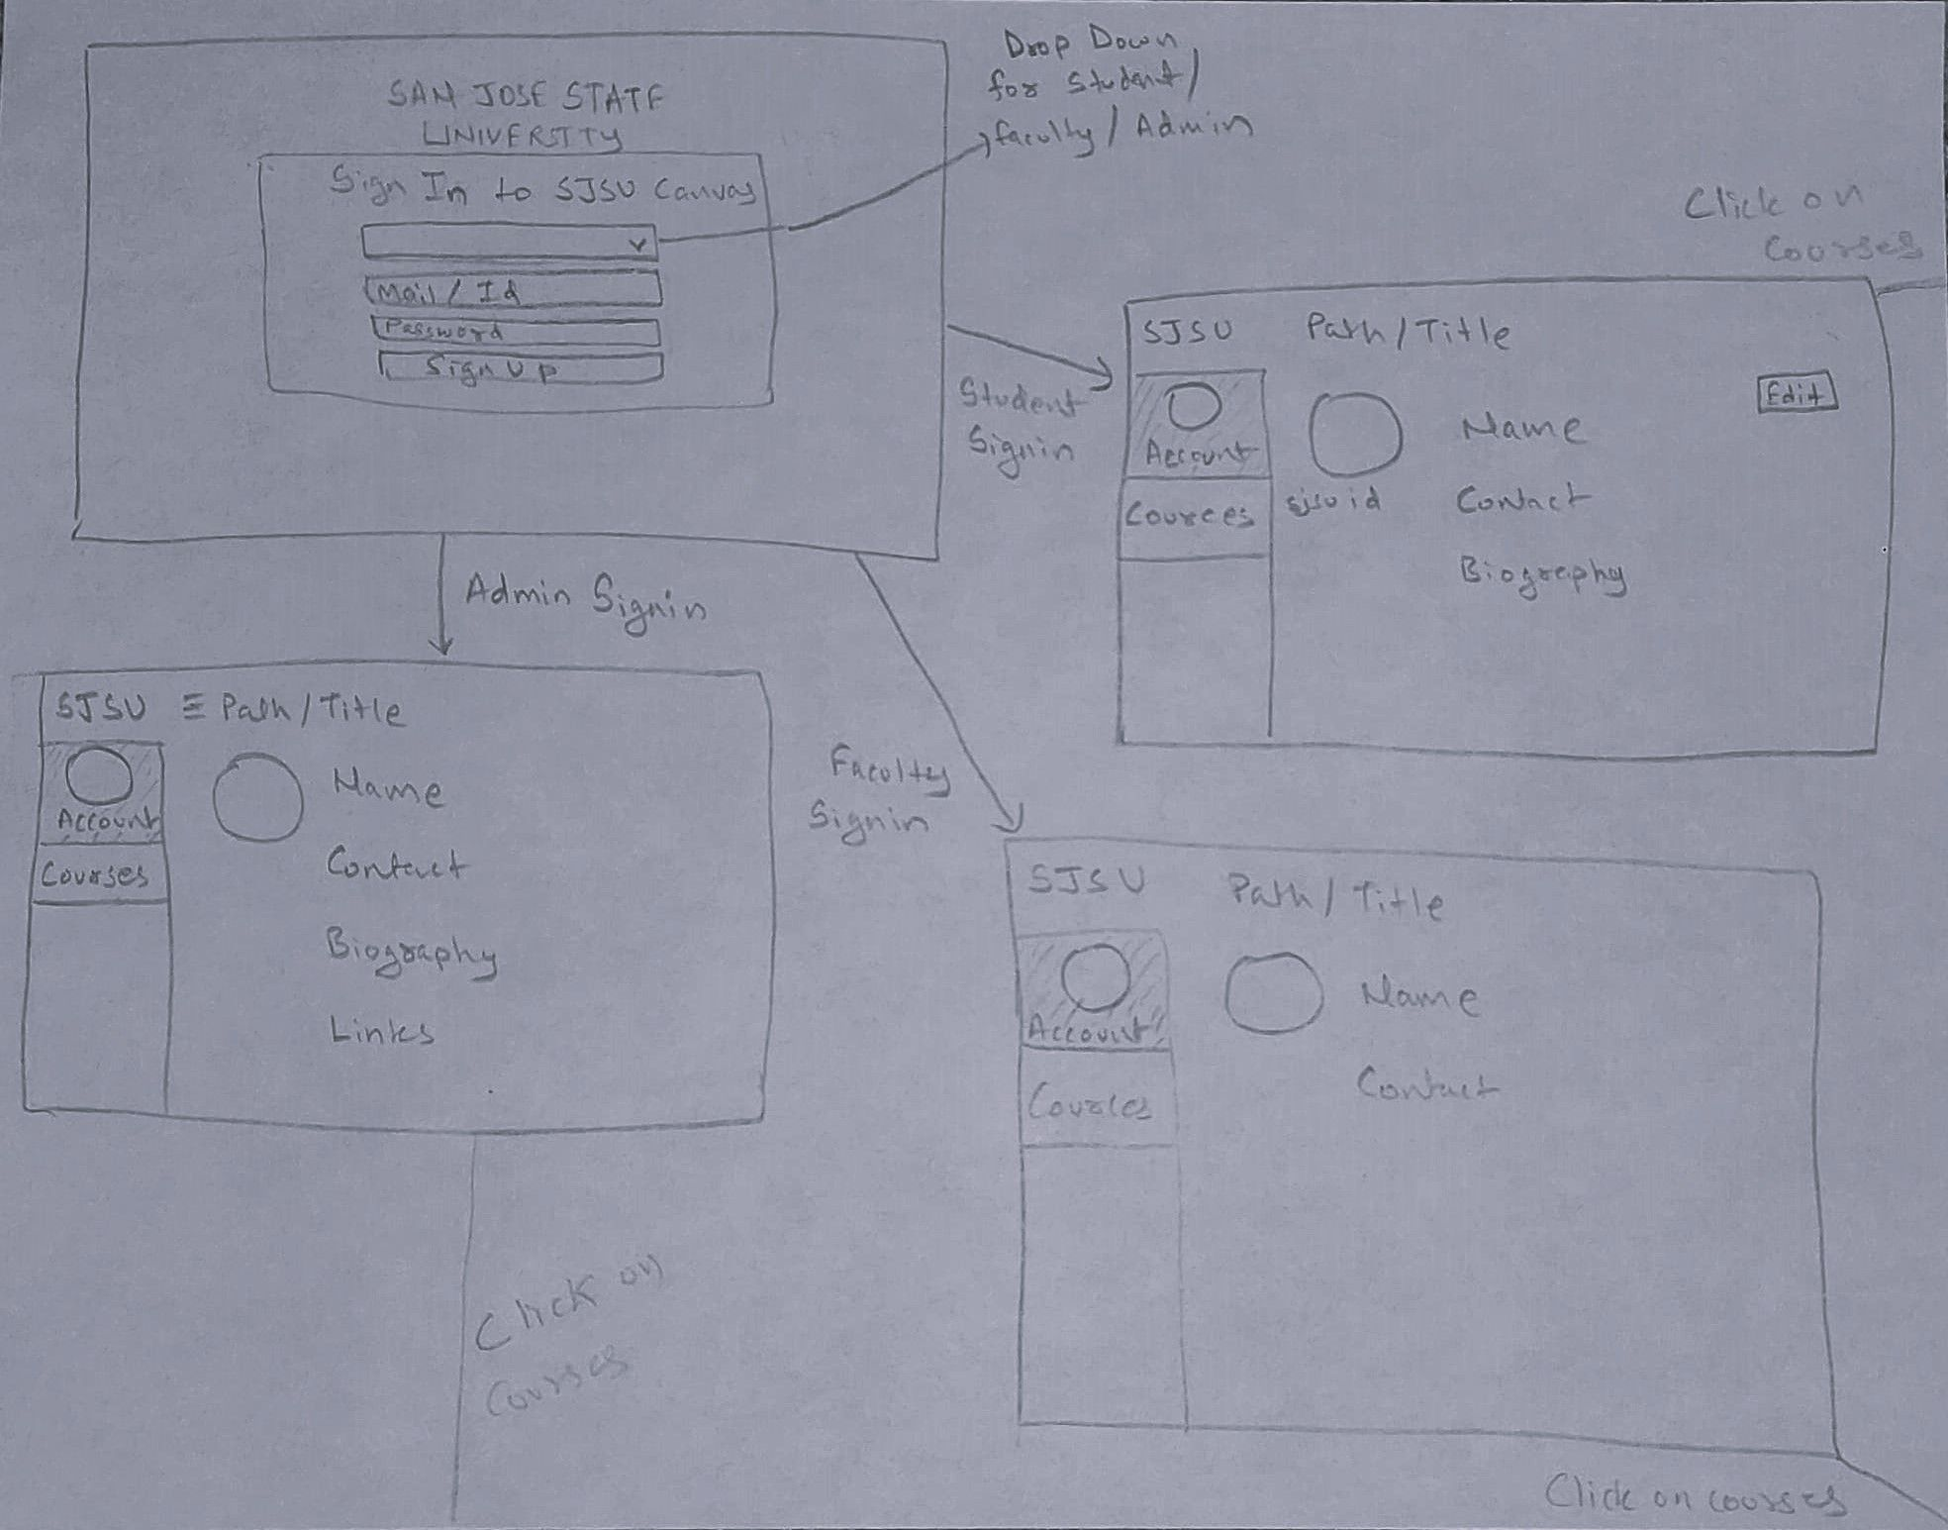

Admin Sign In:

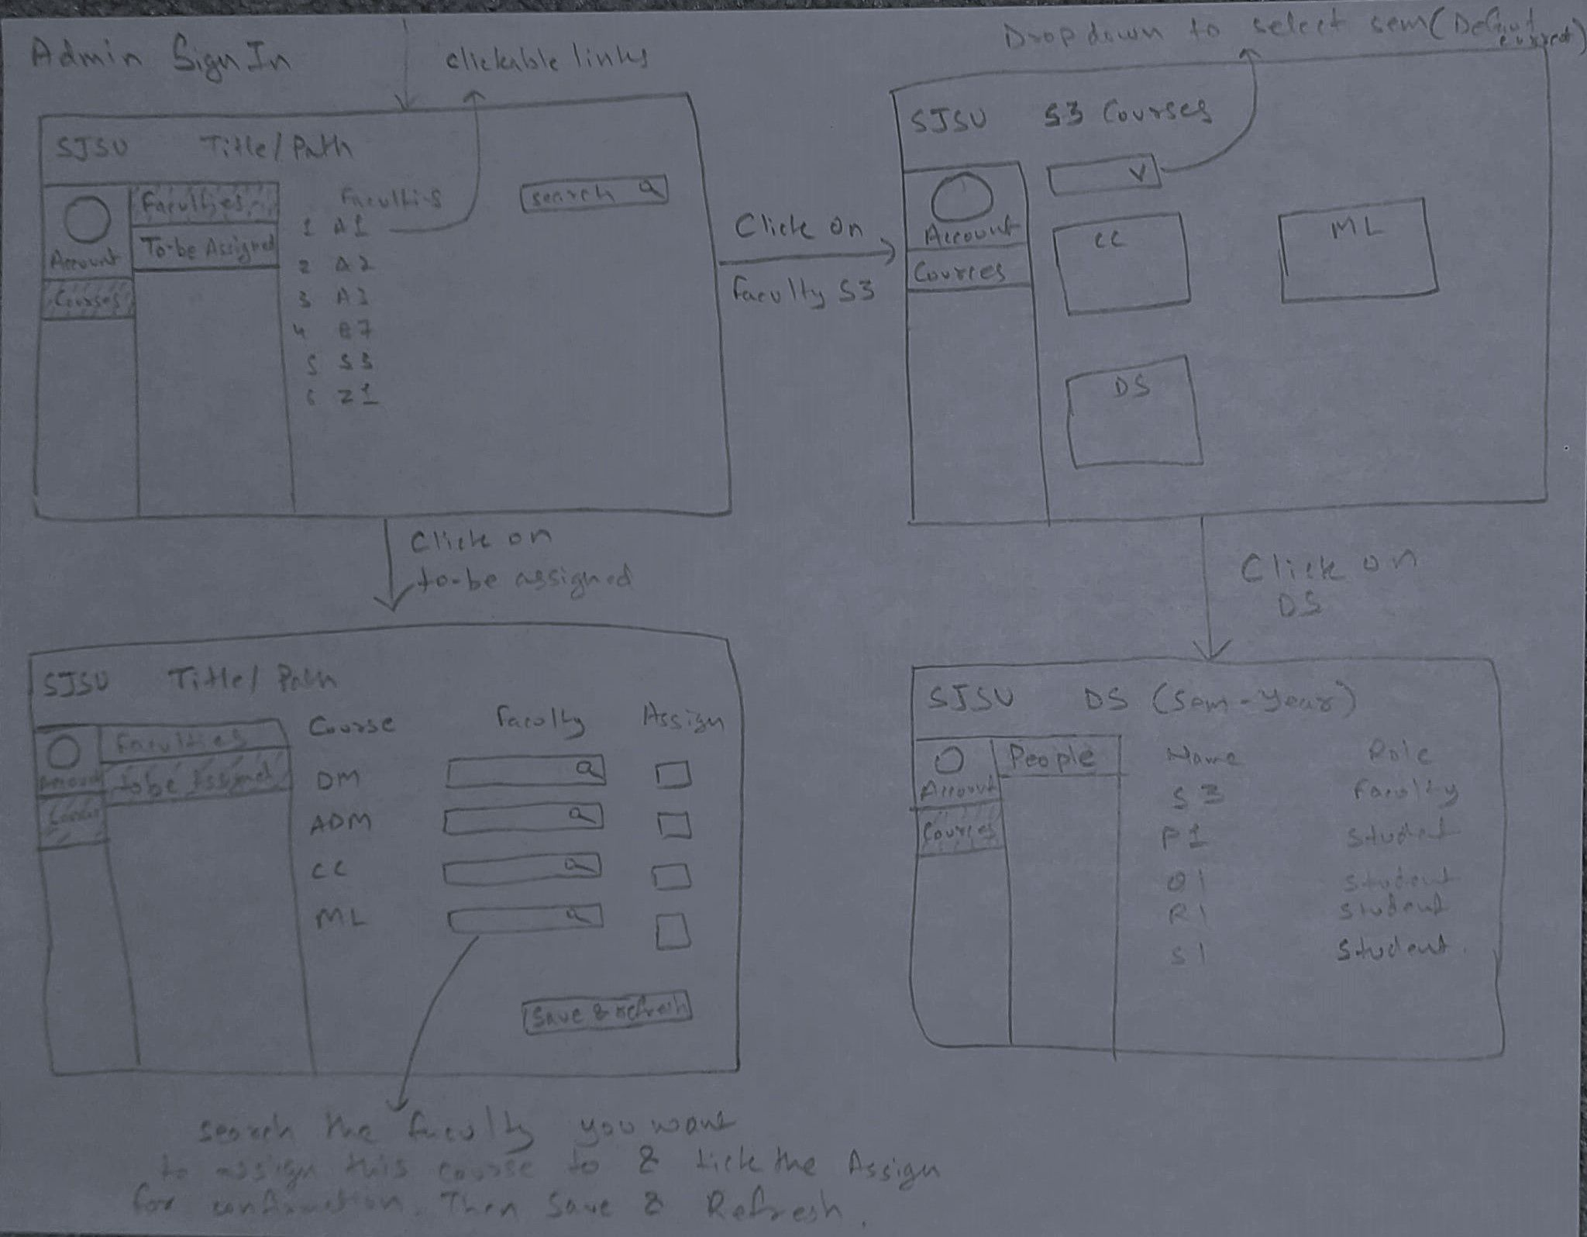

Faculty Sign In:

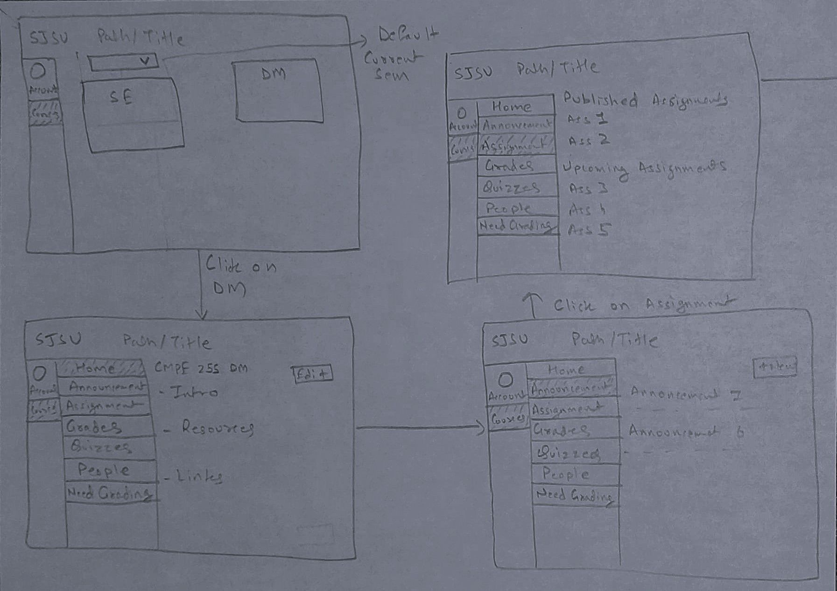

Faculty Sign In 2:



Student SignIn:

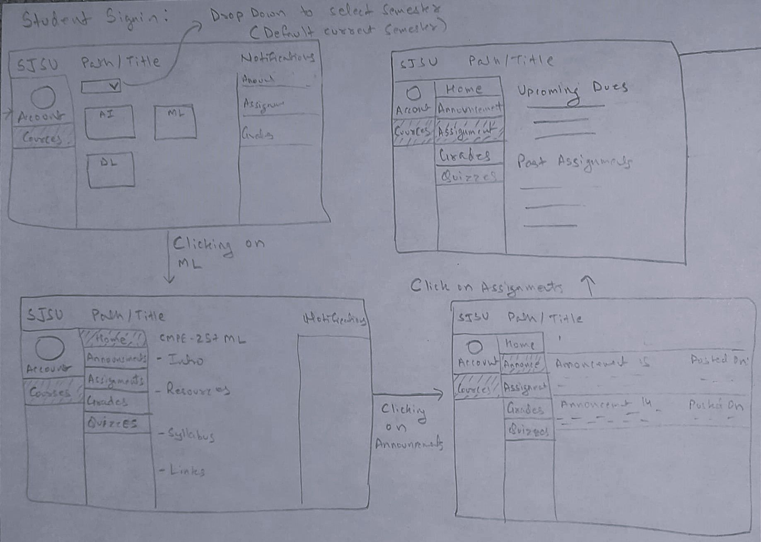

**Sprints**

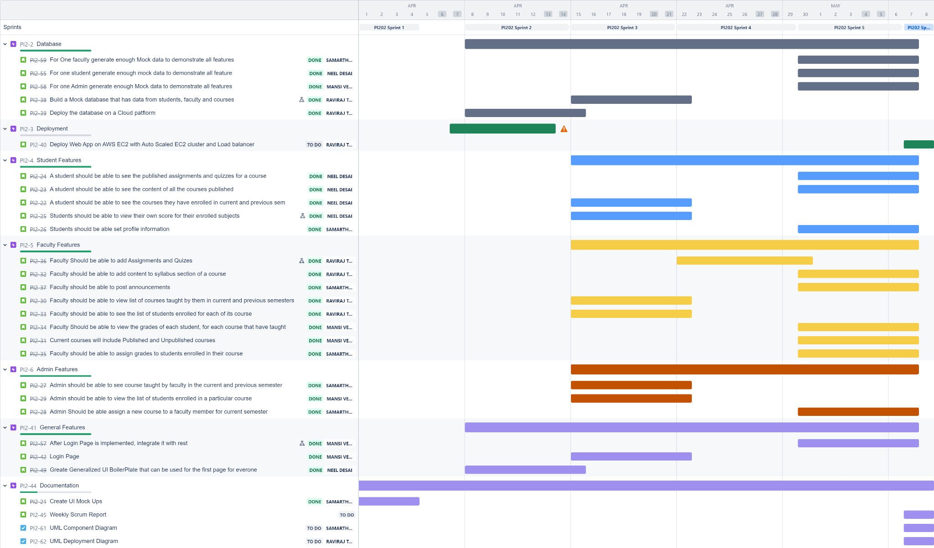

**Sprint Burndown charts (Sprint 1 - Sprint 6)**

Estimation Field: Issue Count  
We followed a weekly sprint, the primary reason being that the team was new to the tech stack, frequent target setting and communication, leads to much quicker knowledge transfer between members and faster development speed.

**Sprint1:**

This sprint primarily focused on getting used to how Jira works, understanding all the requirements and creating user stories, creating a database schema and setting up the development environment 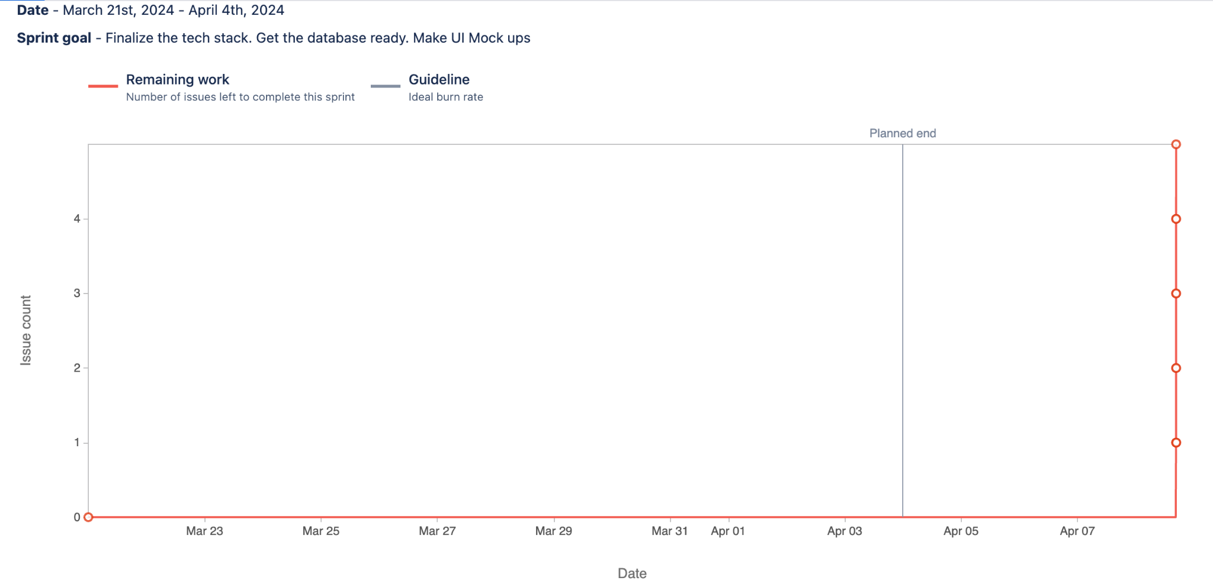**Sprint 2:**

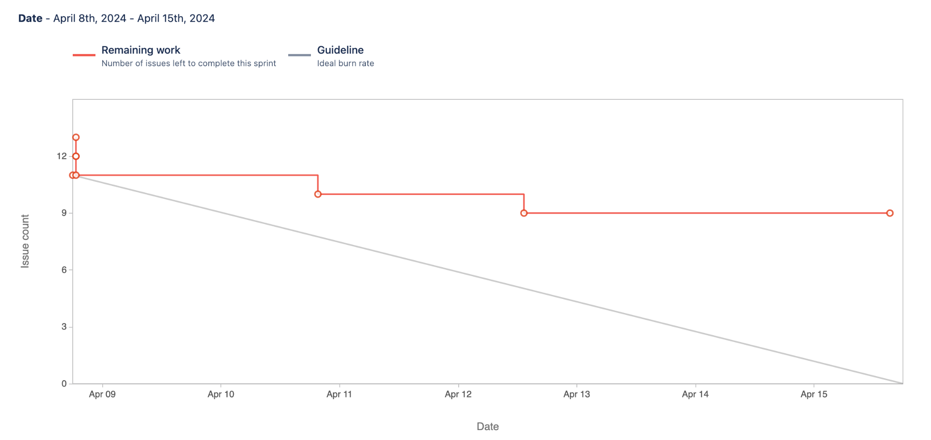

**Sprint 3:**

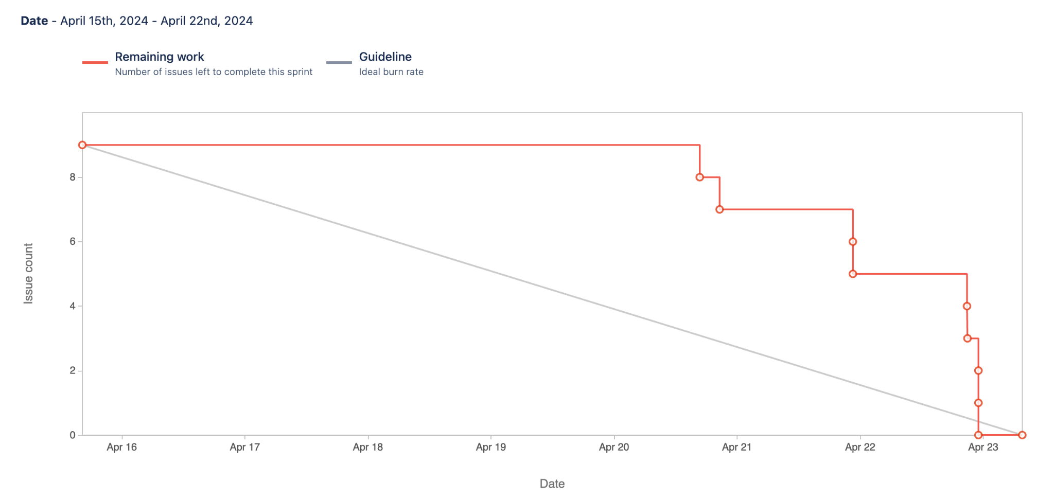

**Sprint 4:**

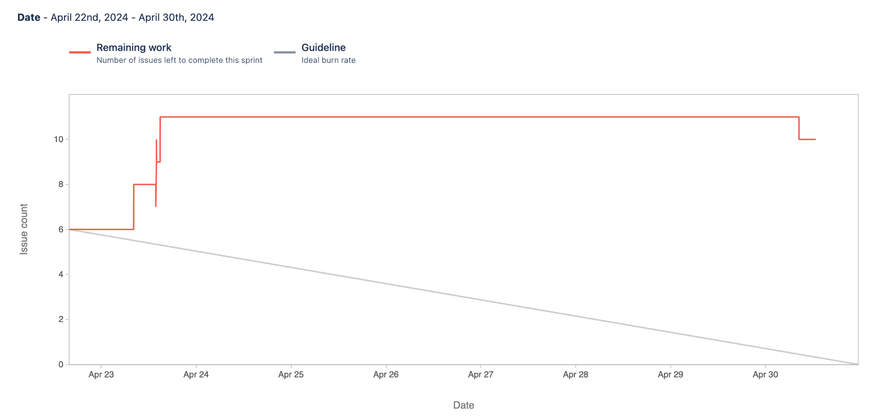

**Sprint 5:**

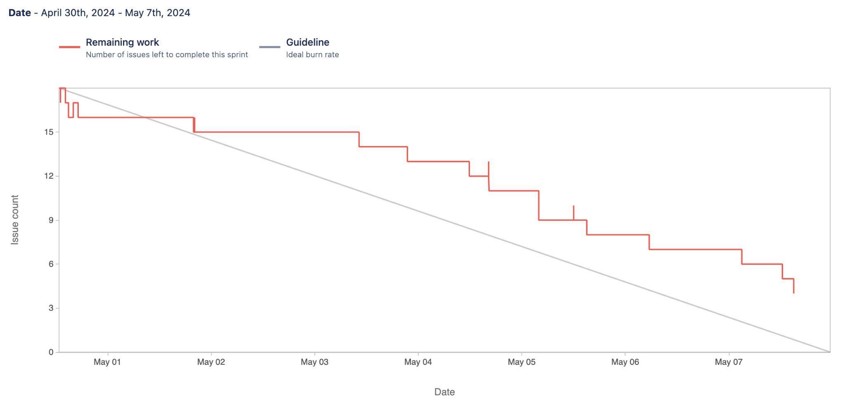

**Sprint 6:**

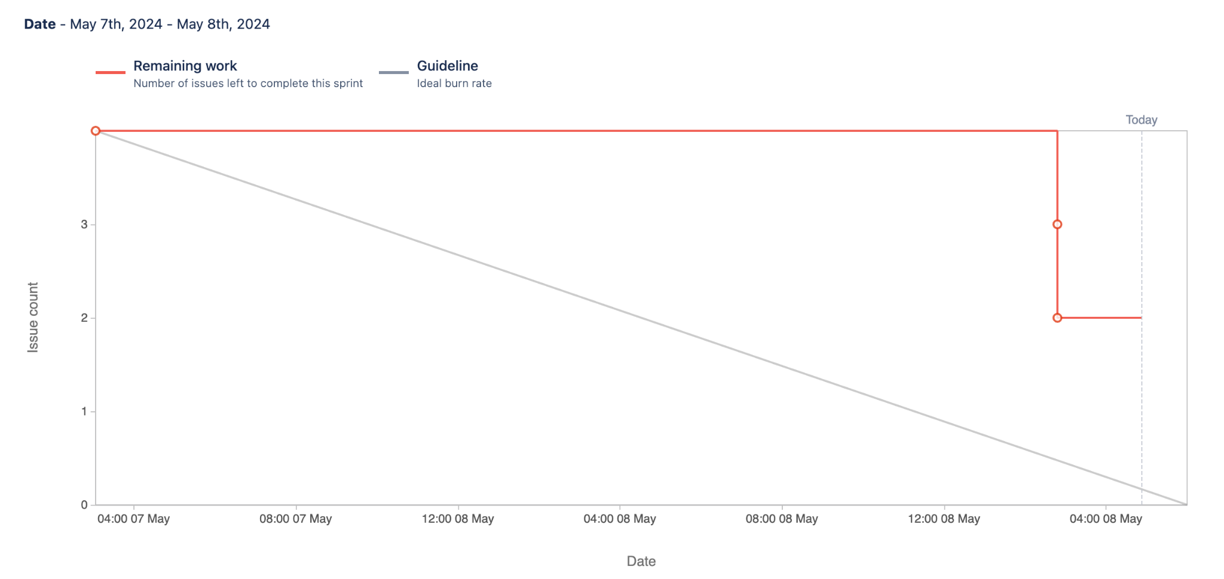

APIs Documentation

1. /get_user_data
   1. Used for authentication and authorization of the user
   2. Takes user id and password as input
   3. Return authentication status and role of the user
2. /get_previous_courses
   1. Role-based API, for students, gives the course the student enrolled in previous semesters, for faculty it gives the courses the faculty taught in the previous semester
   2. Takes user_id and role as input
   3. Returns a list of dictionaries, where each dictionary has course title and course code
3. /get_current_courses
   1. Role-based API, for students, gives the course the student enrolled in previous semesters, for faculty it gives the courses the faculty taught in the previous semester
   2. Takes user_id and role as input
   3. Returns a list of dictionaries, where each dictionary has course title and course code
4. /people_in_course
   1. Used by faculty and admin to find the students enrolled in a course
   2. Takes the course code as input
   3. Returns a list of dictionaries, where each dictionary has full name of the student and their email address
5. /get_unpublished_faculty_courses
   1. Used by faculty to get the list of unpublished courses
   2. Takes user_id of the faculty as input
   3. Returns a list of dictionaries with each dictionary having the course code and course title
6. /get_tograde_assignment
   1. Used by faculty to get all the assignments for a course that are not graded
   2. Takes course code as input
   3. Return a list of dictionaries where each dictionary contains assignment content, the student id,assignment id and total points for the assignment
7. /assign_grade
   1. Used by faculty to assign grades for assignments, to students
   2. Takes the assignment id, the student id and the grade to be assigned as input
   3. Returns success or failure status in json format
8. /profile_data
9. Common API for all the roles, returns the profile information for the user.
10. Takes input as the user_id
11. Returns a list of dictionaries, return a dictionary with full Name as concatenation of first and last name, user_id, bio, linkedin link, github link, and notification preference.
12. /edit_profile
13. Common API for all the roles, updates the profile information for the user.
14. Takes input as the user_id, bio, linkedin link, github link, and notification preference.
15. Updates the bio, linkedin link, github link, and notification preference based on the changes the user entered.
16. /get_courses_to_be_assigned
17. API only used by the Admin for fetching the unassigned courses from the future semesters.
18. Doesn't need an input (Courses retrieved based on the logic future course and faculty_id is ‘0’ (default unassigned course faculty_id))
19. Returns a list of dictionaries each having the course_id, course_title, and semester.
20. /get_courses_by_faculty
21. API only used by Admin to retrieve all (history, current, future) the courses under a faculty.
22. Takes faculty_id as input.
23. Returns a list of dictionaries each having the course_id, semester, and course_title .
24. /get_faculty_user_ids
25. API only used by the Admin for fetching all the faculties to be displayed as an option to assign them courses.
26. Doesn't need an input (retrieves all the faculty based on role)
27. Returns a list of dictionaries each having the user_id, full name.
28. /faculty
29. API only used by the Admin for fetching all the faculties there are in the db to display the faculty list.
30. Doesn't need an input (retrieves all the faculty based on role)
31. Returns a list of dictionaries each having the user_id, course_id, full name.
32. /assign_course
33. API only used by the Admin to assign unassigned courses from the future semesters.
34. faculty_id is passed.
35. Updates the faculty_id that is going to teach the course.
36. /get_scores_by_student
37. API only used by the Faculty to view scores of each student.
38. Doesn’t need an input (retrieves all the student based on role)
39. Returns a list of dictionaries for each student with all the scores.
40. /get_announcement
41. API is used by students and faculty to view the announcements for a particular course.
42. Doesn’t need input (retrieves all the announcements based on student and faculty role basis)
43. Returns a list of all announcements.
44. /get_course_grades
45. API is used by students and faculty to get all the grades based on the courses.
46. Doesn’t need input (retrieves all the grades for students in case of faculty)
47. Returns a list of all grades for the student.
48. /create_assignment
49. The create_assignment() endpoint processes POST requests, initially checking for valid JSON input. It then extracts necessary details such as course_id, title, content, is_published, total_points, assignment_type, and due_date from the request data.
50. Using the extracted information, it constructs an SQL query to insert a new assignment record into the assignments database table. The details include the course ID, assignment title, content, publication status, total points, type of assignment, and the due date.
51. If the database insertion is successful, the function returns a success response with a 201 status code. If an error occurs during the process, such as a database exception, the error is logged and a 500 status code is returned, alongside an error message describing the issue.
52. /toggle_publish/<quiz_id>
    1. The toggle_publish() endpoint accepts a quiz ID as a URL parameter and a publication state (is_published) from the JSON payload to toggle the publish status of a specific quiz in the assignments table.
    2. It constructs and executes an SQL query to update the is_published field for the specified quiz, handling the change in publication status dynamically based on the provided input.
    3. Upon successful update, the endpoint returns a success message; if any errors occur during the process (e.g., database errors, invalid input), it captures and logs the exception, returning an error message and a 500 status code to the client.
53. /get_course_content
54. The get_course_content() function serves as an API endpoint that handles POST requests aimed at retrieving detailed content for a specific course.
55. It first validates the incoming JSON data for the presence of a course_id, then executes a SQL query to fetch the course title, content, and syllabus from the database.
56. If successful, the course data is converted into a dictionary and returned as JSON; if any error occurs during this process, an appropriate error message and status code are returned to the client.
57. /edit_course_content
58. The edit_course_content() function processes POST requests to update specific fields of a course, such as title, content, and syllabus, by validating the JSON data received and executing an SQL update query based on the provided course_id.
59. After updating the course data, it retrieves the updated course_title and course_content to confirm the changes, converting the query results into a dictionary format to return to the client.
60. The function handles potential errors robustly, returning an appropriate error message and status code if the JSON data is invalid, if the database update fails, or if an internal server error occurs during the process.
61. /create_anouncement
62. The create_assignment() function processes POST requests to create new assignments by validating JSON data received from clients, extracting relevant fields such as course_id, title, content, and others.
63. It constructs an SQL query to insert the extracted information into the assignments table in the database, handling the assignment's publication status, type, total points, and due date.
64. If the data insertion is successful, it returns a confirmation message; otherwise, it handles exceptions by logging the error and informing the client of a server-side error through an appropriate response.
65. /get_assignment
66. Used by faculty and students based on the role (using user_id).
67. It starts by validating the request using the validate_request function, which checks if the necessary keys ('role' and 'course_id') are present in the request.
68. Depending on the role provided in the request:
    1. Student: If the role is 'student', it retrieves the current assignments for the student for a specific course ID using a function named student.get_current_assignmments(). There seems to be a typo in the function name (get_current_assignmments should probably be get_current_assignments).
    2. Faculty: If the role is 'faculty', it retrieves current assignments (potentially for all courses or specific to the faculty's requirements) using faculty.get_current_assignmments(). This function takes the entire JSON request payload as an argument, which might include additional parameters needed specifically for faculty.
69. /get_quiz
70. Validation: Checks if the request includes necessary keys ('role', 'course_id') and validates them.
71. Role-Specific Data Retrieval: For validated requests from students, retrieves current quiz data for the specified course.
72. Error Handling: Returns an error message if the role is incorrect or validation fails.
73. /get_syllabus
74. Validation: Ensures the request contains 'role' and 'course_id' and checks their validity.
75. Syllabus Retrieval: If the requester is a student, fetches the syllabus for the given course.
76. Error Response: Generates an error for invalid roles or failed validation.

Diagrams

1. ER Diagram

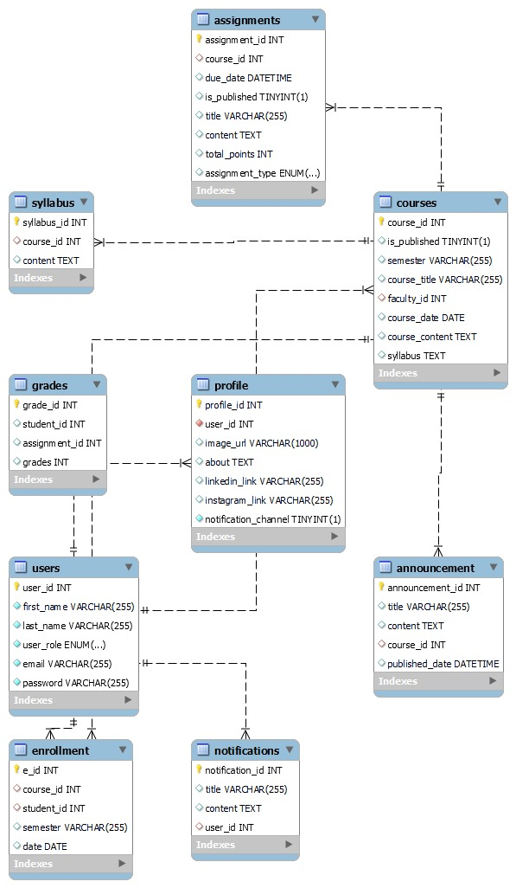

1. Component Diagram

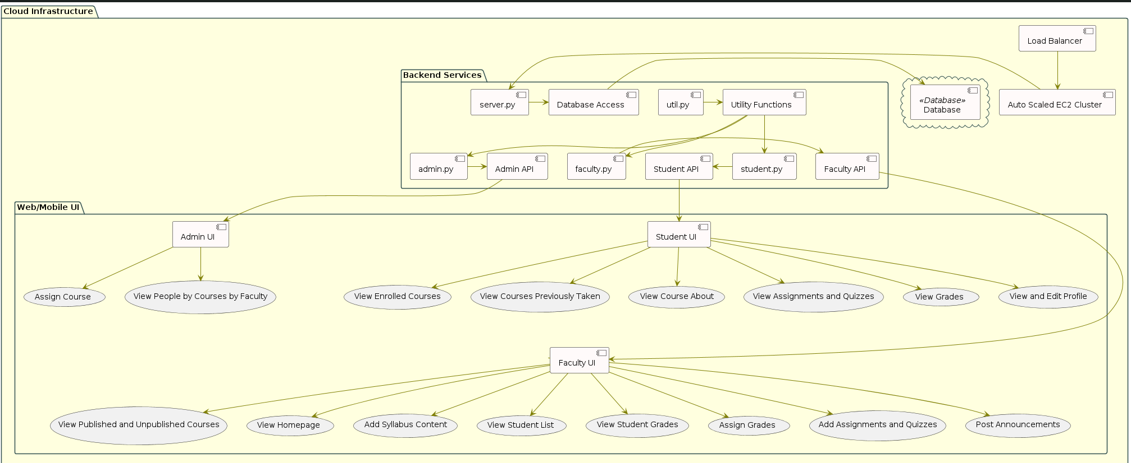

1. Deployment Diagram

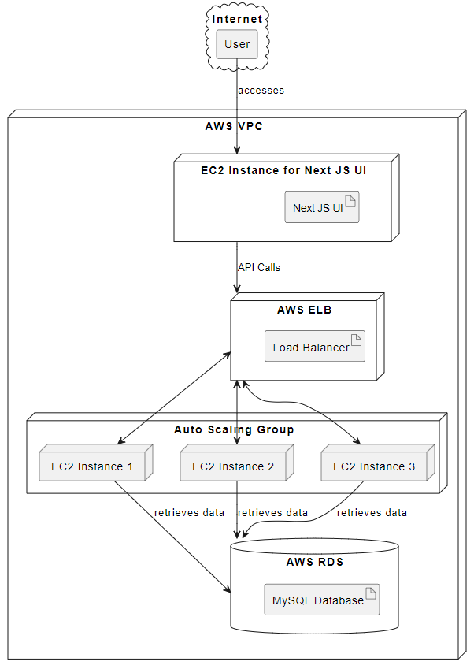

Cloud configurations:

Cloud Deployment url:

Frontend: <http://ec2-18-144-82-123.us-west-1.compute.amazonaws.com:3000>

Backend: <http://ec2-18-144-82-123.us-west-1.compute.amazonaws.com:5000>

To connect with EC2 we have used mobaxterm software and for converting the ssh keys to RSA we have used putty gen:

Created SSH keys in order to clone it from the main branch team-project-pi

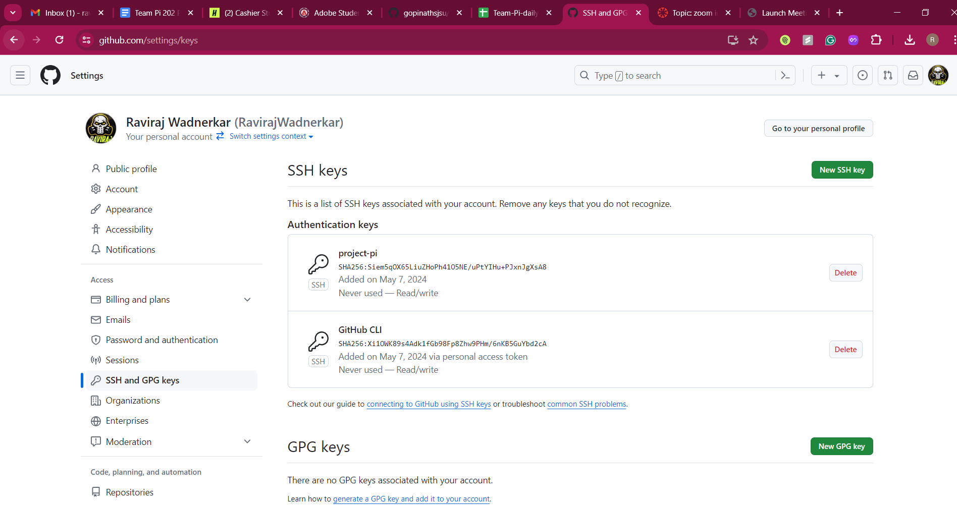

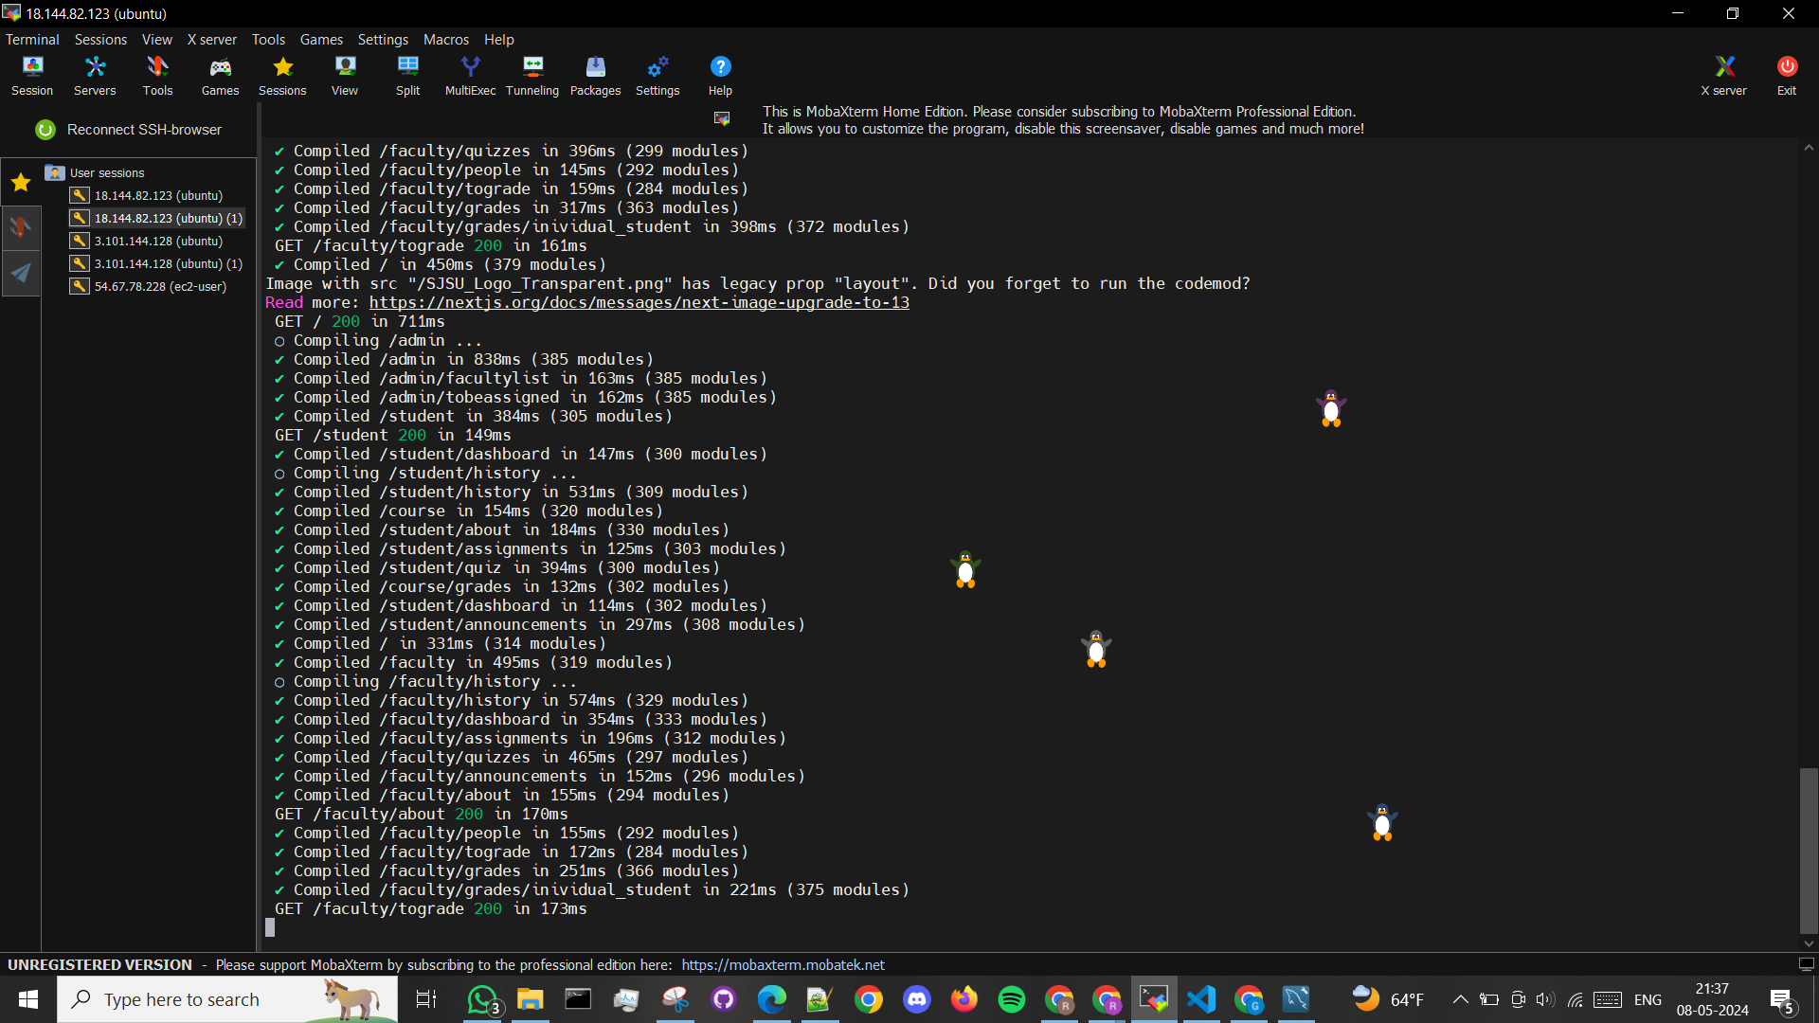

EC2 instances:

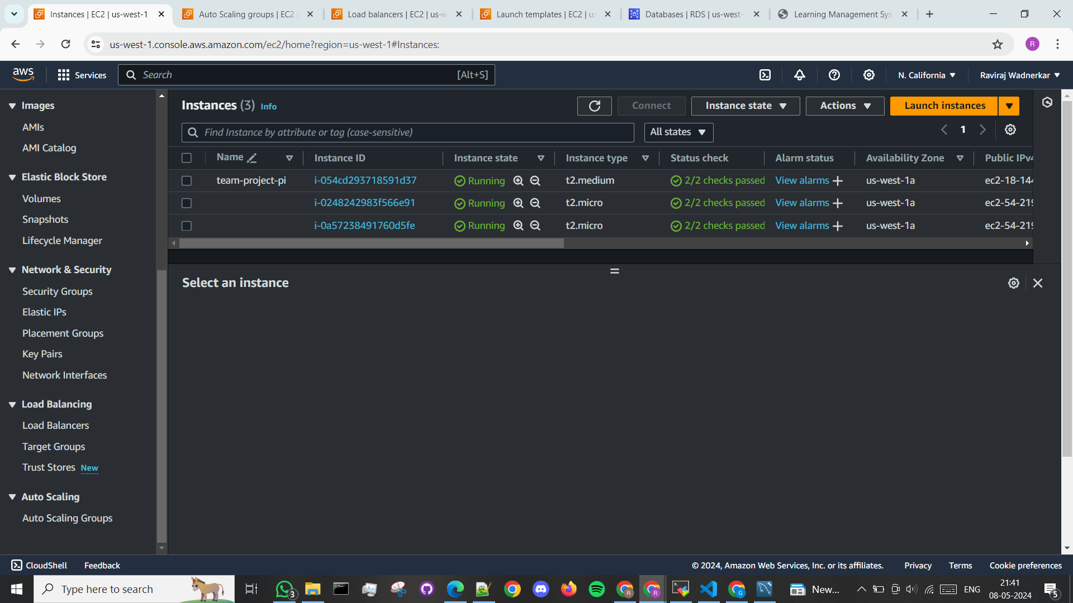

Autoscaling:

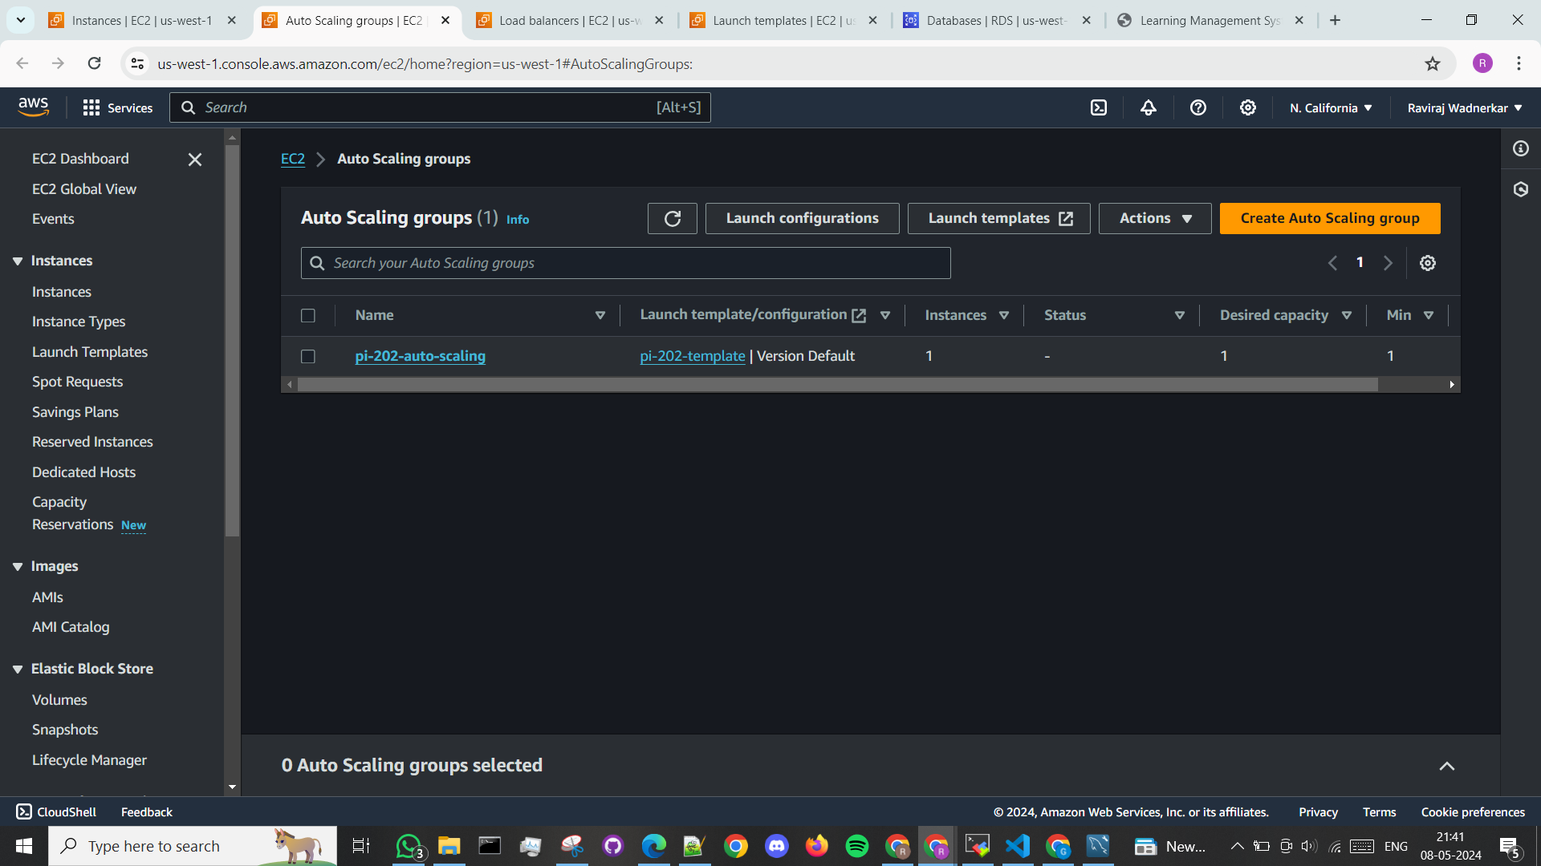

Load Balancers:

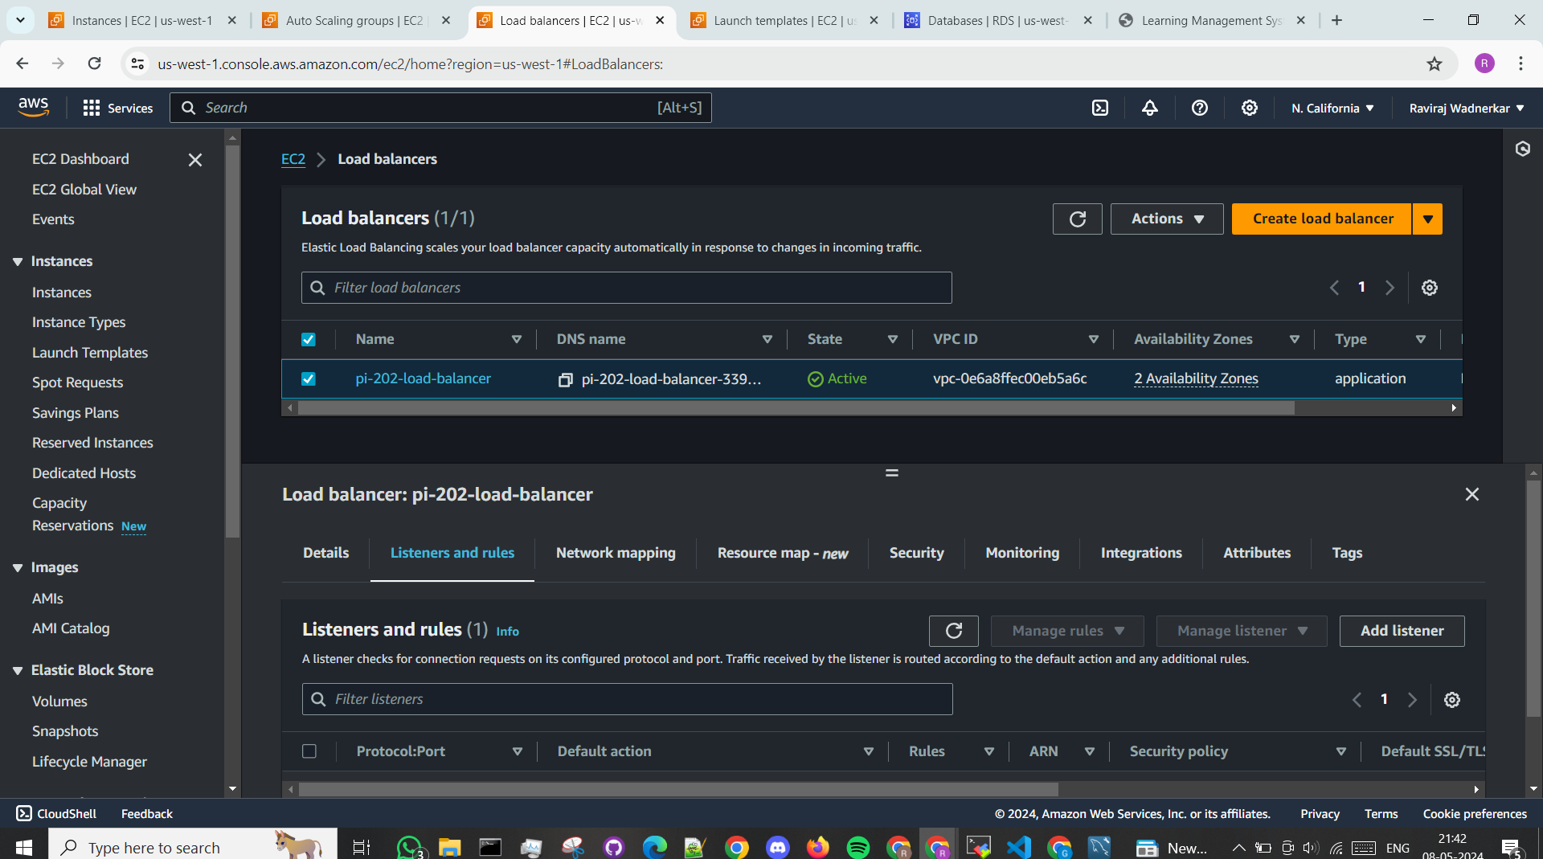

Launch template:

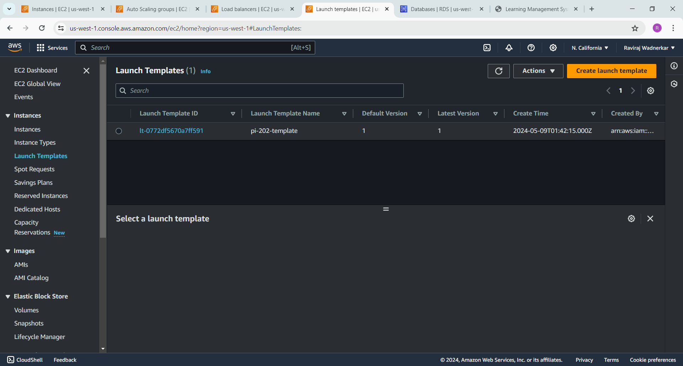

AWS RDS to host our database:

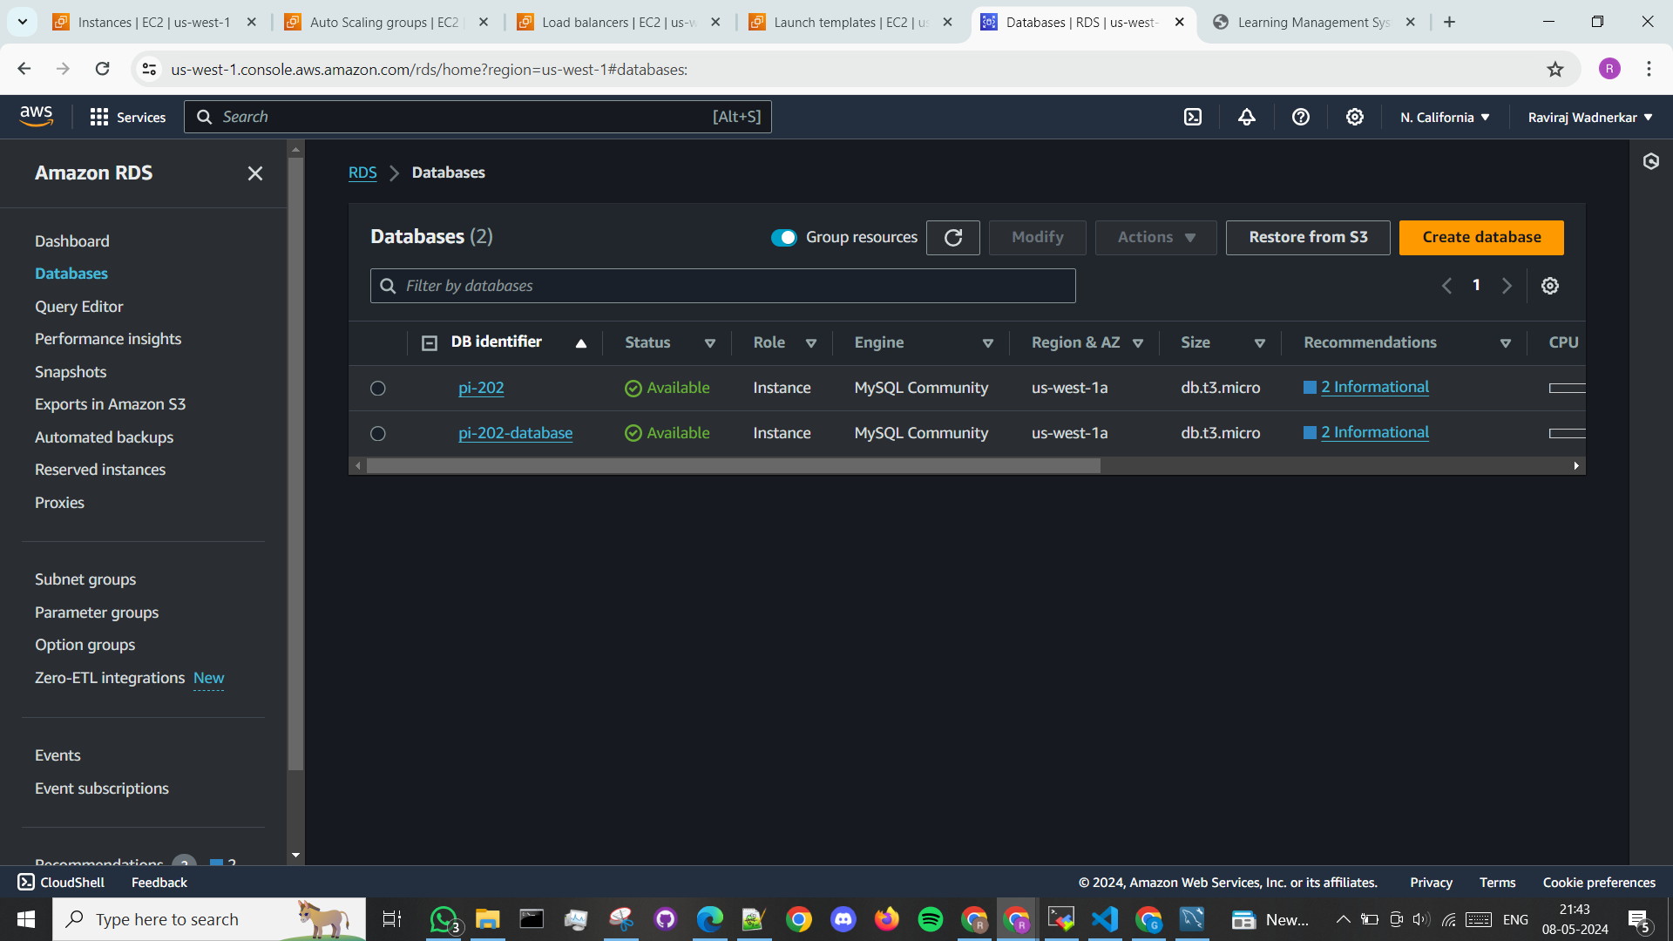

AWS S3 bucket:

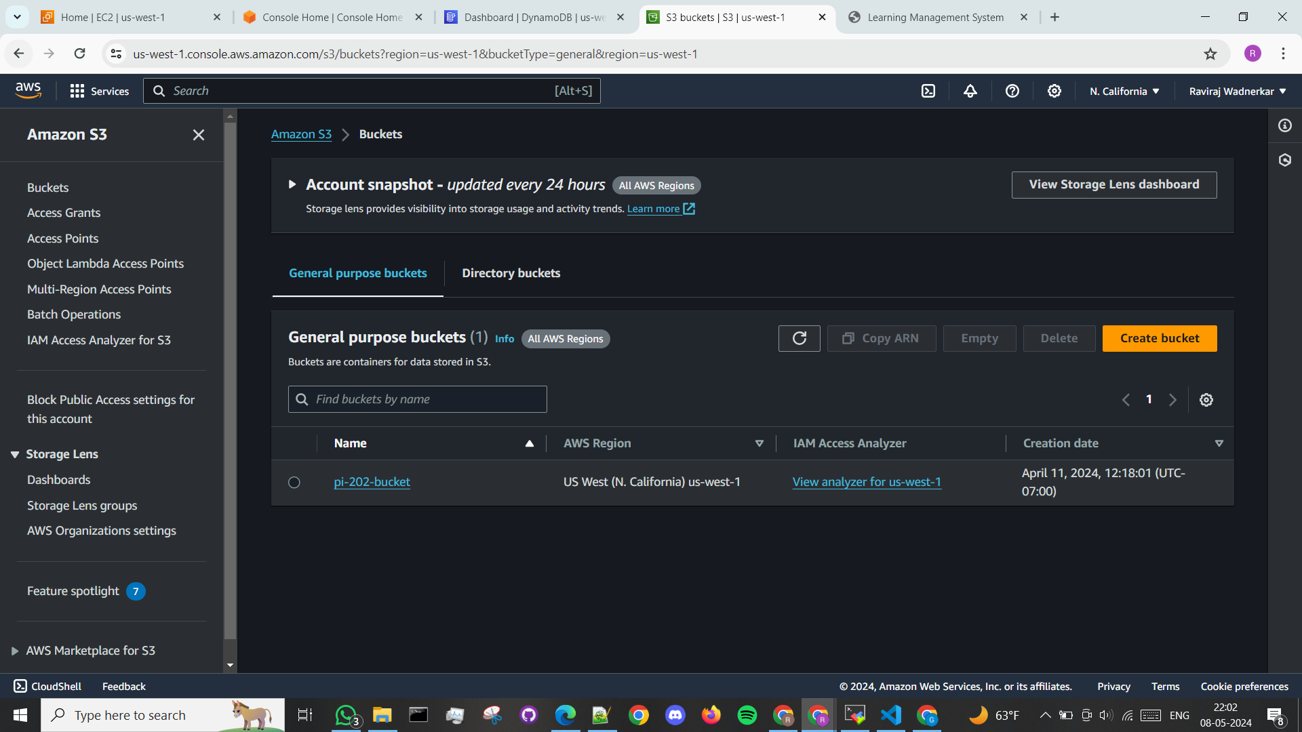

A sample of working demo:

Login page:

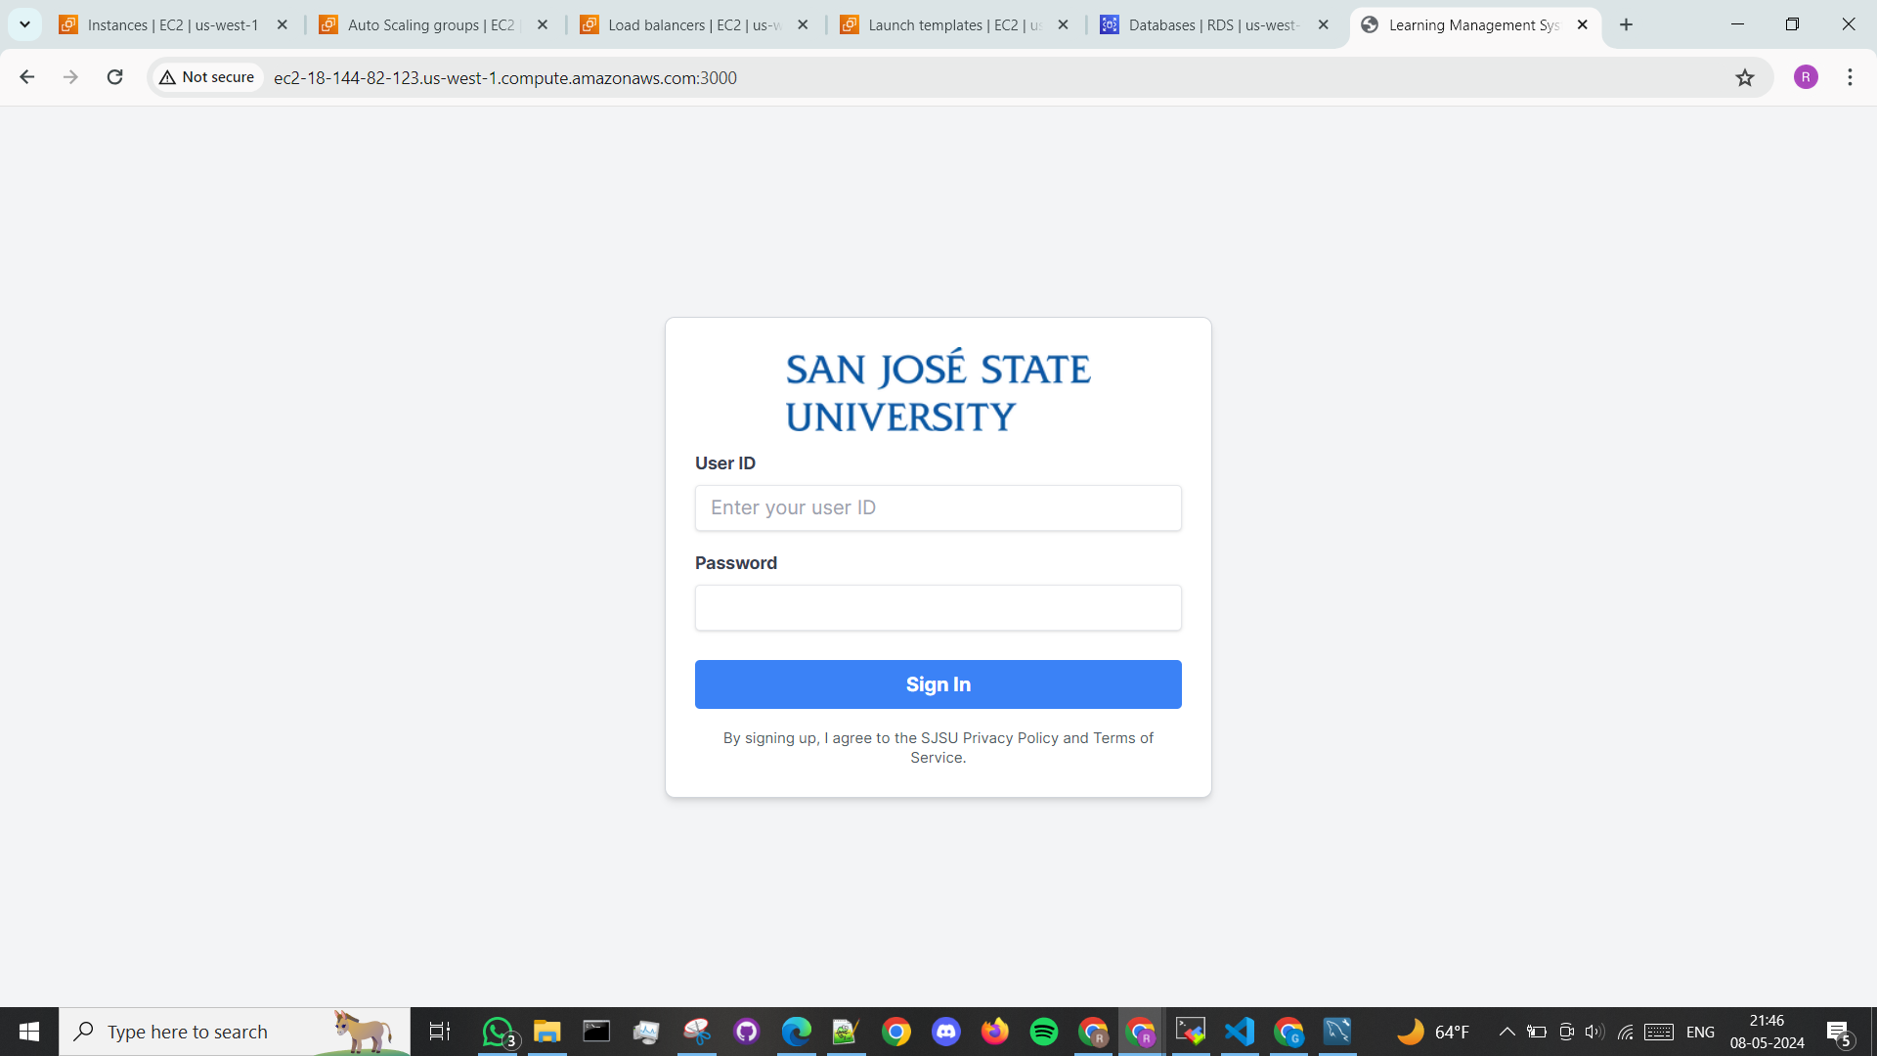

Student sample page:

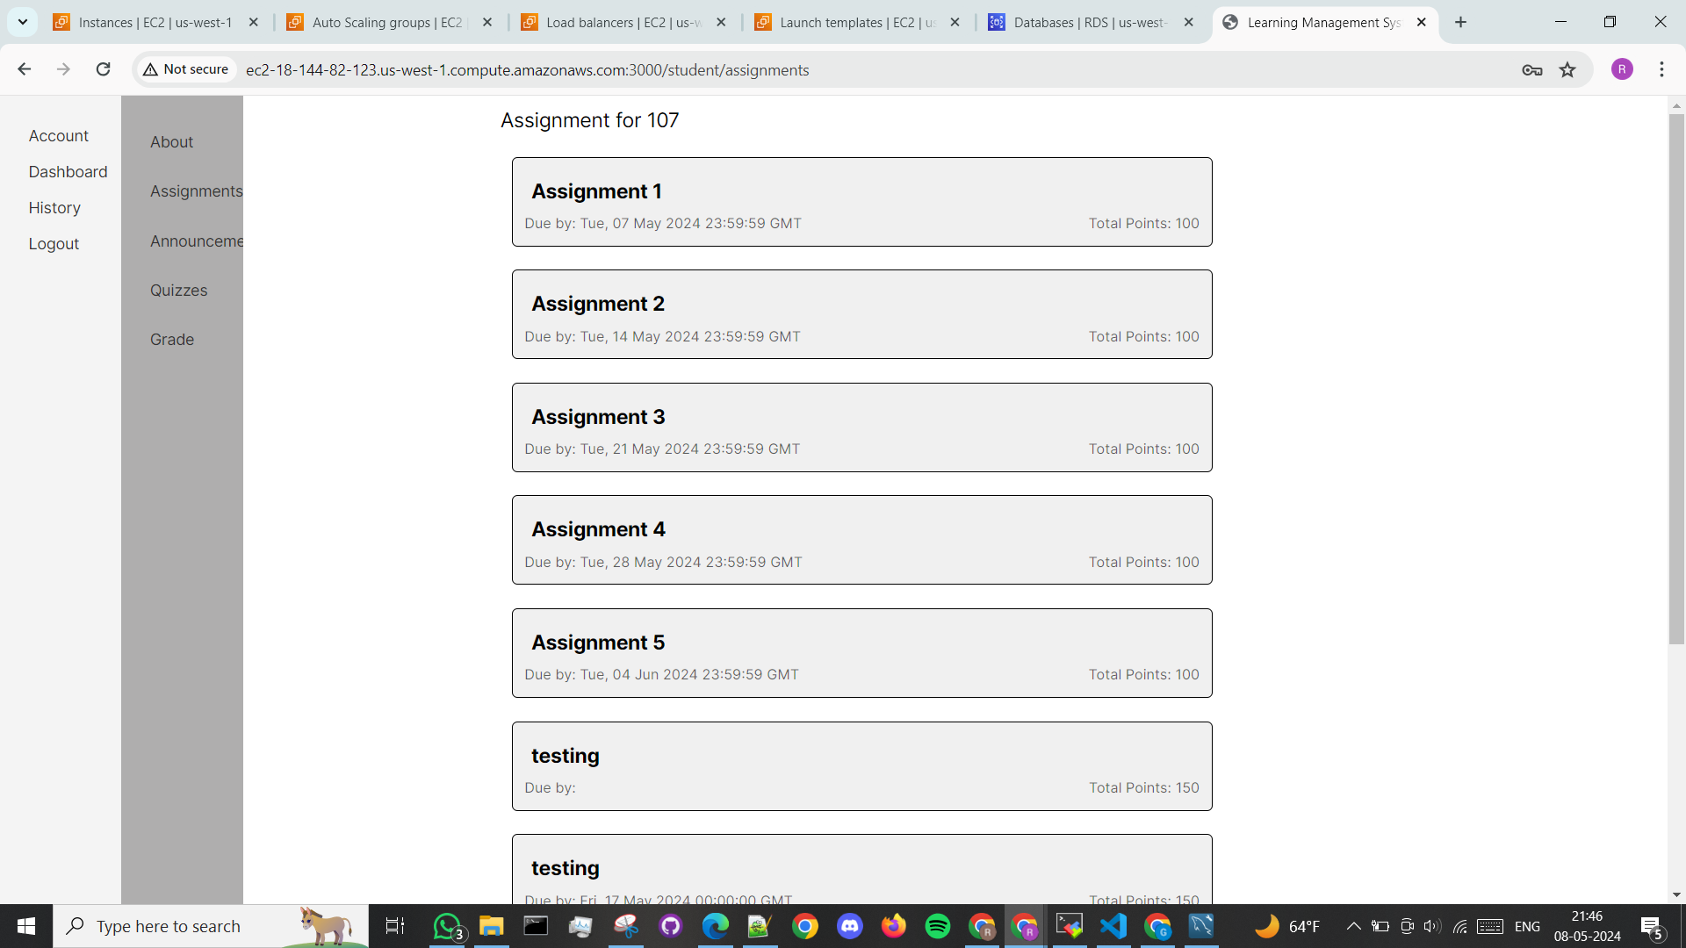

Faculty sample page:

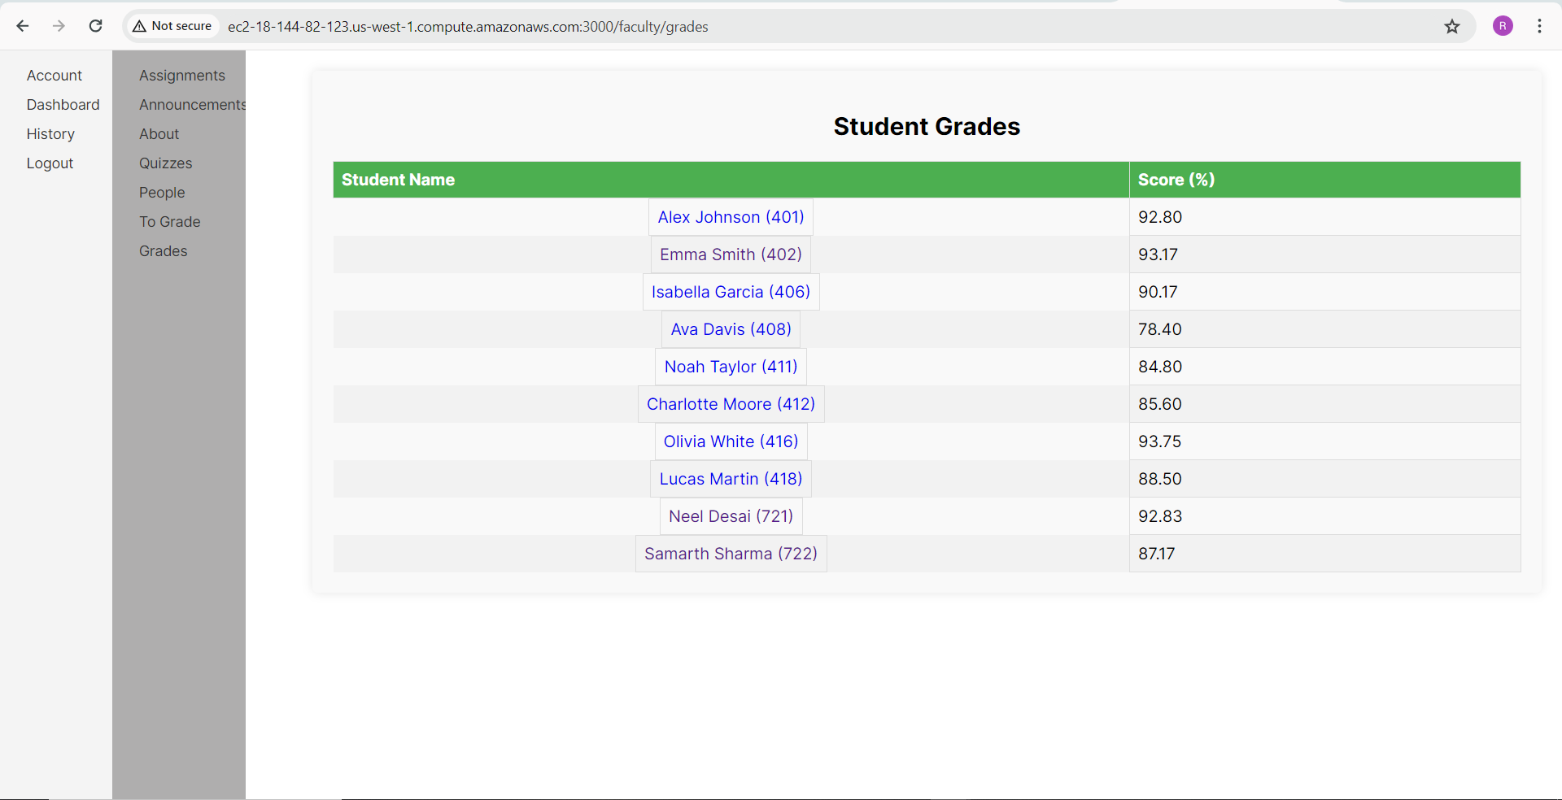

Admin sample page:

